prolonged inhalation of wheat flour or wheat dust.

What are the main parts of the wheat grain?
The endosperm is the middle of the grain and contains a large amount of starch and smaller amount of gluten protein. This is the energy store for the new wheat plant. The germ is at one end of the grain and contains the embryo of the new plant. The germ is rich in essential oils, folic acid and other B-vitamins, and antioxidant tocols. The covering on the grain is the bran, which is a thin edible skin made up of cellulose and other insoluble dietary fiber. The bran also contains polyphenolic compounds that are anti-oxidant, flavor and color
compounds. Just underneath the bran there is the aleurone layer which is rich in soluble fiber, proteins, minerals and more B-vitamins.

What about phytic acid & phytates?
Much of the mineral content of whole wheat is trapped in compounds called phytates, or the related phytic acid. These can be found in the bran and aleurone, together with an enzyme, phytase, that will begin to release the minerals as soon as the grain is moistened. Full release of the minerals occurs by the time wheat grain is fully sprouted or when whole-wheat dough is sourdough leavened. Acidity enhances the enzyme activity. Whole wheat contains significant amounts of potassium, calcium, magnesium, phosphorus, iron, and zinc.

Bakers yeast or sourdough?
Bakers yeast is designed primarily for making refined flour breads containing some cane sugar; generally it is a selected single yeast species, particularly good at fermenting sucrose. It is usually supplied in a cake or dried form and is added in high initial concentration to bread dough.
Ideally sourdough is produced in a dough or batter consisting of whole-wheat or whole-rye and water, with some of the grain sprouted to supply extra enzymes. It is sour or acidic because lactic bacteria thrive in this medium. Few other microorganisms can survive in the acidity except some yeasts that are particularly good at leavening bread. Sourdough is valuable for whole-wheat leavening because it helps release minerals, ferments some of the starch and soluble fiber, modifies gluten, stabilizes thiamin, produces flavor and acts as a natural preservative for the finished bread.

Is baking soda healthy?
Scones, biscuits and soda bread are usually made with baking powder containing baking soda (sodium bicarbonate) or with baking soda alone. These breads do not need time to rise before baking and are considered very convenient. However, baking soda is alkaline in its action and breaks down thiamin. There is a high risk that breads made with baking soda or baking powder, will fail to provide the needed thiamin.

© Monica Spiller. December 2016

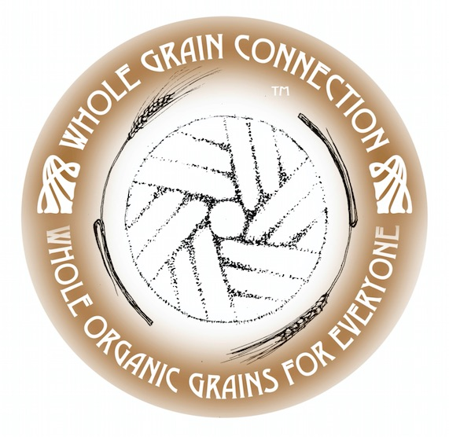

Wheat Q&A

Why does 100% whole-wheat matter?
In much of the world wheat is our most basic food. Many people eat it at every meal. The wheat seed is the same as the whole-wheat grain. There are enough nutrients in the seed to make a complete wheat plant, but if any part of the seed is removed the plant fails to form. Similarly when we eat wheat, we need to eat the whole seed in order to receive the full benefits of all that wheat can offer, e.g. the major nutrient in the wheat grain is starch, which gives us energy. But if we only eat the starchy part of wheat we miss out on the B-vitamins that are needed to properly convert that starch to energy. Also whole-wheat supplies bran, which is mostly dietary fiber. The usual symptom that bran is missing in our diet is constipation.

What is Junk Food?
Plant foods such as grains, sugar cane and sugar beet become junk when they are purified. When the starch and protein are separated from the rest of the grain to make white flour it becomes junk food. It is junk food because it no longer contains the vitamins and minerals that would be present in the whole wheat. These are what make white flour properly useful to give us energy and build cells. White sugar is junk food because it has been purified to be free from any other nutrient substance except sugar.

What is enriched flour?
B-vitamins were not properly understood until about 1940. They are needed in our food, so that we can properly obtain energy from starch and sugar. When this need was established, governments in the USA, Canada and Britain mandated the addition of some of the missing nutrients to be added to white flour to make it closer to the whole wheat. The B-vitamins, thiamin, niacin, riboflavin and folic acid, and mineral iron are now added. The flour is then called “enriched flour”. But the dietary fiber, vitamin E, phenolic anti-oxidants, essential oils, minerals such as potassium and zinc and much more that would be in whole wheat, are still missing.

What is organic unbleached flour?
In the early 1990s, white bread flour was often bleached with added chemicals. Also some people were suspicious of the added vitamins and minerals, because in some cases they are synthetic. So an exception was made for “organic unbleached flour”, which is not legally required to have B-vitamins and minerals added back. The flour is junk food as a result. Most people are eating a balanced diet, but if all the bread eaten is deficient in vitamins and minerals, then people will become sick from the deficiencies. This is the most likely reason for the increase in complaints by many people that they cannot tolerate wheat. The description of this flour as “organic” gives people a false sense that it is healthy.

What are B-vitamin deficiency symptoms?
When insufficient B-vitamins are taken in with starch and sugar, the first symptom is a lack of energy and a temptation to eat yet more starch or sugar to compensate. With insufficient thiamin, sugar and starch are only partly converted to energy and the rest is converted to fat, so there is a tendency to become overweight and pre-diabetic. Inadequate amounts of niacin cause diarrhea, forgetfullness and skin irritations. Folic acid deficiency is associated with Alzheimer’s disease. Lack of folic acid during early pregnancy causes babies to be born with spina bifida. Extreme lack of B-vitamins is fatal.

How is white flour made?
Modern white flour was invented around 1880. The wheat is moistened so that the bran can be easily and completely removed first. Next they cut off the germ and this leaves pure endosperm, which is starch and gluten protein and very little else; it is this that is ground into white flour. All this is accomplished with several sets of rollers. Hence the method is known as roller milling.

What is white wheat flour?
All wheat grains have a bran skin, that takes on color depending on the phenolic compounds in the skin, similarly to grapes some of which are transparent and green and others dark purple. White wheat has almost colorless bran, whereas red wheat bran is dark red brown. Whole wheat flour from white wheat is practically white in color, and is attractive to those who like light colored bread.

What is gluten?
Gluten is the particular kind of protein in wheat endosperm that has the unique property of trapping the gases given off during bread fermentation, and creating a spongy texture. There are other proteins in the germ and associated with the bran and the aleurone layer, but these do not help to form the spongy texture in bread.

What is a wheat allergy?
All true allergies are caused by a protein of some kind. Allergy symptoms are usually seen as sneezing or eye and skin irritations. Once an allergy is established in a person, there is a risk of extreme reaction to the offending protein in the form of asthma or anaphylaxis. Wheat contains several kinds of protein each in different parts of the grain. It is therefore possible for susceptible people to become allergic to wheat perhaps as a result of

